48E. Trading the Open: Breakout of yesterday’s range

- Failed BO of Yesterday’s High or Low
  - If market went above the high of yesterday, reversed, went up and reversed again (either above or near the high of yesterday), it is a 2nd entry sell for a failed breakout of yesterday’s range. If the 2nd reversal came from a bear bar closing on its low, it is a reasonable setup for a swing short.
  - Examples:
    - 2nd entry Short at B7 for failed breakout above HoY.
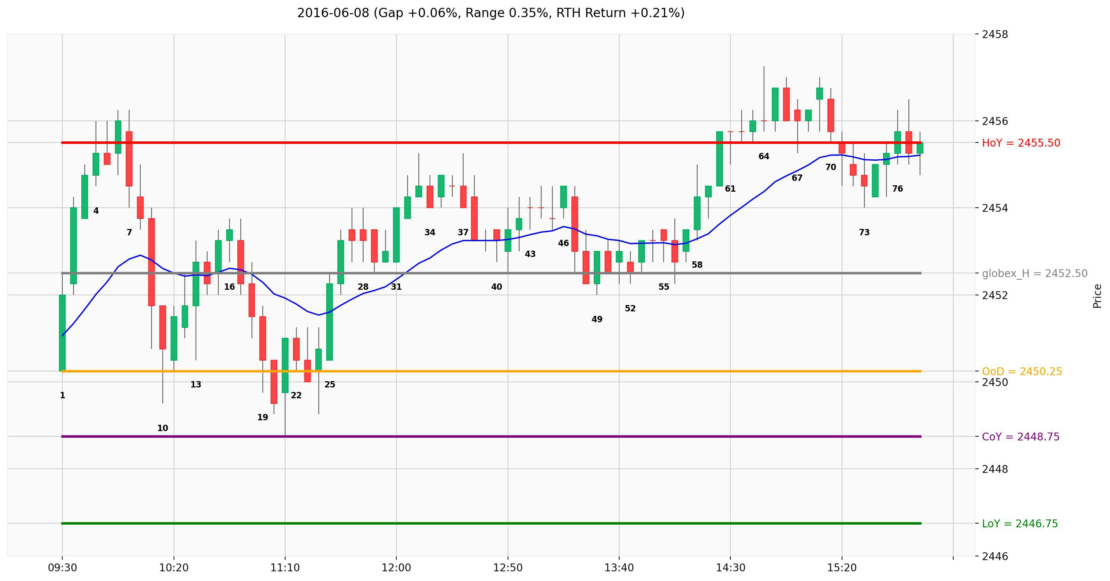
    - 2nd entry Short at B8 for failed breakout above HoY. Here the 2nd attempt came from slightly below HoY.

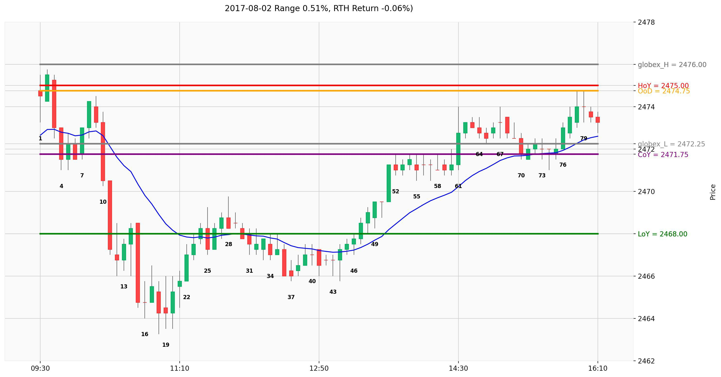

  - Example of failed breakout below LoY, 2nd entry long at B10
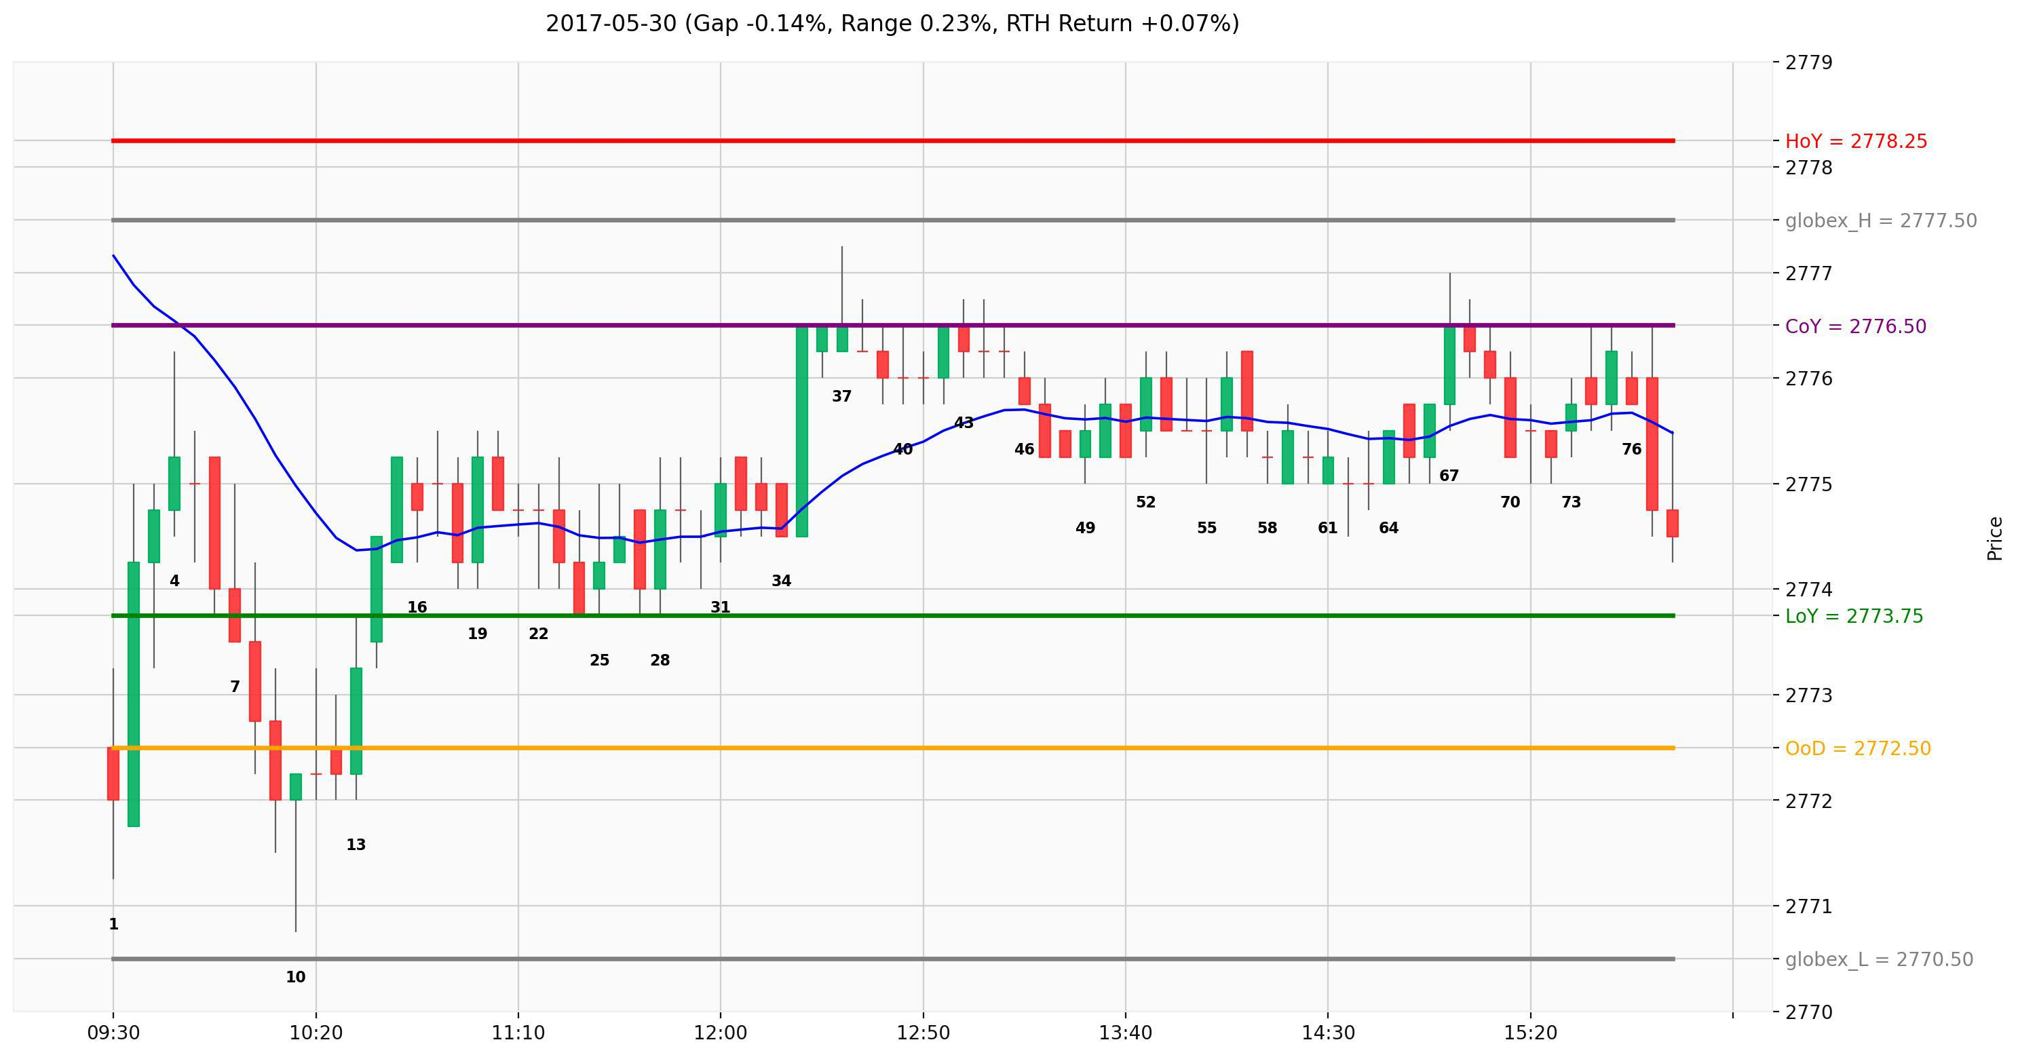
  - There are many ways particular 2nd entry trades may setup. What is important is to look for a reversal and a second reversal from a good signal bar.

- Another example. Market gapped down below LoY and the EMA on 60m chart (not shown)
- B2 was a reasonable buy after market broke out below LoY and is reversing, so was B8 for same reason, and a higher low
- But B10 was the third reversal down so a wedge, at 5m EMA (and around 50% of the gap), so B10 was a reasonable sell signal as well
- B10-B15 strong bear BO but immediate reversal on B16 with no follow through.
  - Remember on the open, regardless of how strong the legs appear, there is a chance higher than you may expect, that it will reverse
- B16 was large lower low double bottom, LL MTR, large 2nd entry buy – ie reversal after 2nd failed BO below LoY.
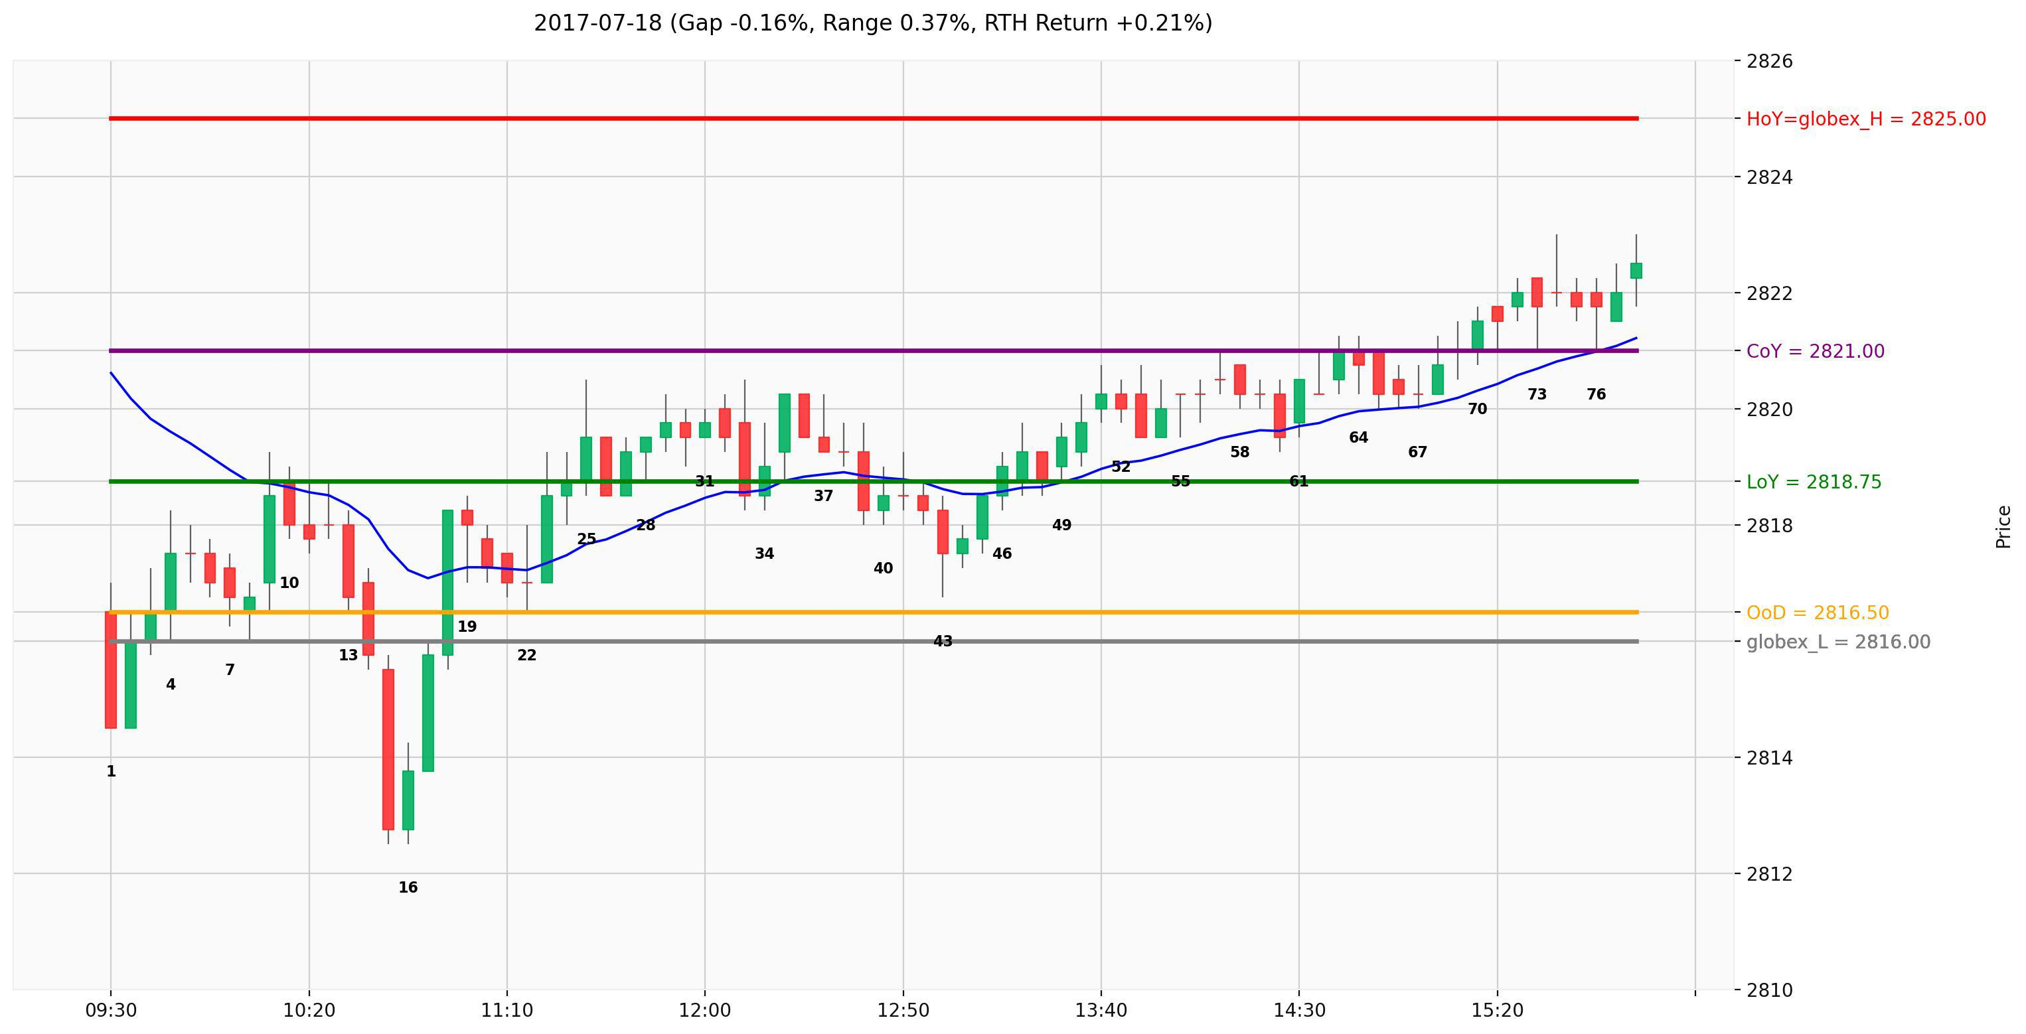

- BO of both sides of yesterday’s range
  - If yesterday’s range is small, there is increased chance today will be an outside day
  - For example on 2017-09-20:
    - B4 2nd micro DT and entry short above HoY
    - B39 2nd entry short after wedge top above HoY
    - B63 parabolic wedge bottom and 2nd entry long for failed BO below LoY (also a micro DB)
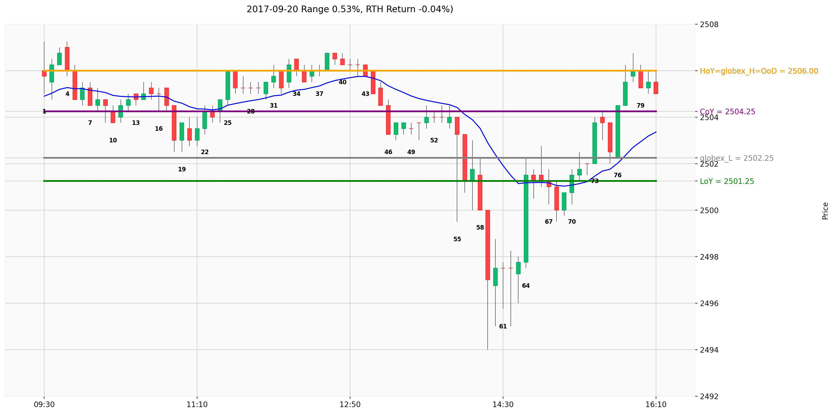

- Here we gapped down below LoY. First reversal on B2 did not get very far. Sold off again and reversed up again on B7 (better to buy above bull bar than bear bar like B6). One can also see the entire price action so far as tight trading range, so could wait for a better buying opportunity, such as 3rd entry buy above B11 and BO bar B13. If one takes any of these buys, stop should be below the low of the day (B5).
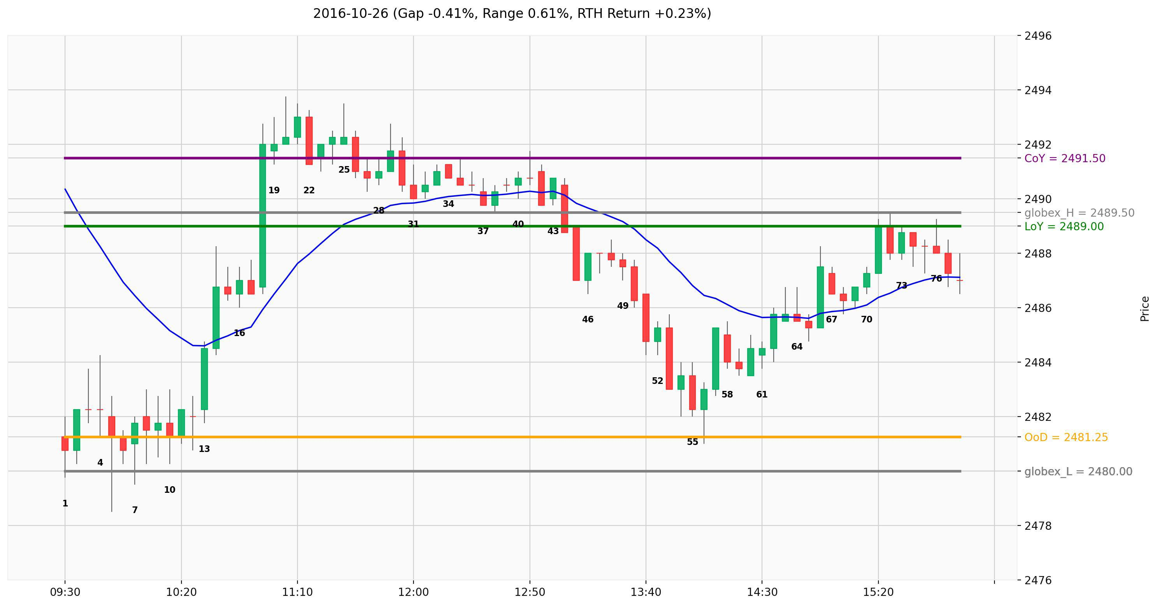

- Failed Reversal of BO of yesterday’s range
  - Every pattern can fail. You should be aware of how it usually fails
  - Here we gapped slightly above HoY and tried to reverse down on B1, 2nd reversal attempt at B4 but immediately reversed from H2 bull flag B5.
  - If traders enter short below B4, and it immediately reverses up, they will/should be very quick to get out, above B5 bad entry bar or above B10, another bull bar closing near its high.
  - Ultimately there was a wedge top and 2nd entry sell below B38 and bears got a swing down.
